February 6, 2024

To Whom It May Concern,

We hereby confirm that the article entitled “Addition of ammonium sulfate to glyphosate in the desiccation of Urochloa Brizantha CV. BRS “Piatã” was translated and then revised by two different professional translators, both native English speakers.
The translators who worked on the article were Michael Germain and Lisa Burger Garcia.
Should you require any further information regarding the work done on this article please do not hesitate to contact us.

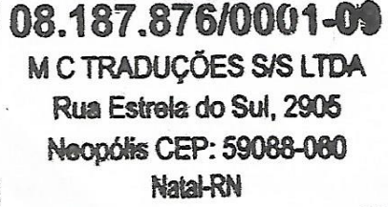
Regards,
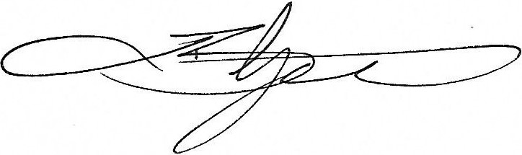

Lisa Burger Garcia
Translator and Co-Founder of Traduciência
www.traduciencia.com.br
Email: contato@traduciencia.com.br
Phone: +55 44 99740 0208

